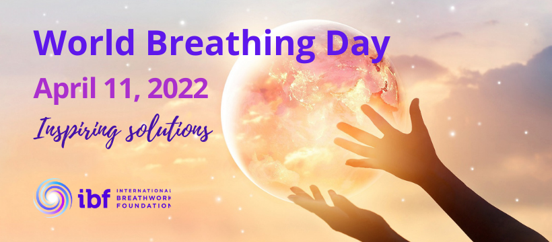

INVITATION to ORGANIZATIONS COMMITTED TO CHANGE TO
GET INVOLVED with WORLD BREATHING DAY 2022

As an Organization closely involved in making a difference in the world, you are cordially invited to participate in the 4th.Global celebration of the “power of the breath”, World Breathing Day 2022 on April 11.

World Breathing Day (WBD) was initiated by the International Breathwork Foundation (IBF) community and is an annual commemorative day that invites everyone to remember, experience and celebrate the healing and unifying power of breath on April 11. Because we all breathe, and we all need the breath, WBD is an important celebration day that touches every human being.

This year, the theme of World Breathing Day 2022 is “Inspiring Solutions”.

Indeed, Conscious Breathing offers a simple, yet powerful tool to create positive change in the world, and YOU can be part of this solution.

We are reaching out to you today to humbly ask if your organization would agree to support World Breathing Day by promoting it within your circles, to your friends, associates, connections, and partners.
WHY SHOULD YOU GET INVOLVED:

Every April 11th, IBF turns the world’s attention to the most vital force in our lives: the Breath. Conscious breathing, in all its forms, is a tool that is easily teachable, available for free because everyone already has access to it, and is powerful in its ability to create unity, transformation, inner peace, health and much more.
The world’s crises are demanding practical solutions in almost all aspects of life - from health and wellbeing (physical, mental and emotional) to climate and ecosystem restoration, to mindfulness and collaboration, peace, unity, and the list goes on
Around the world, many events, such as lectures, breathing experiences, panels, etc. are organized for WBD, and some include internationally renowned breathing experts. Many people will simply give themselves the time during this day, to become conscious of their breathing, and to connect to all humans and creatures that breathe, as well as to the biosphere (the oceans, forests and soils) that make breath - and life itself possible on this beautiful little blue pearl of a planet.
We hope this email will inspire you to join us in sharing a moment of conscious breath while promoting healing, spreading unity and peace.
HERE IS HOW YOU CAN GET INVOLVED
1. Host an event or activity celebrating WBD in your own community, for the people who already know and follow you. Plan your event so that it addresses “inspiring solutions” for your community or for the world, that come from the simple practice of breathing consciously.
Register your event between now and April 1st, so that it can be published in the Worldwide Calendar of WBD Events, as well as on the IBF website and social media.
Make every effort to offer your event or activity for free (or by donation) to ensure that no one is left out. If your event cannot take place on April 11, go ahead and do it on another date, and please remember to mention that you are celebrating “WBD 2022”.
- For guidelines and suggestions for your WBD 2022 event: click here
- Registration form for your event: https://forms.gle/DK2GEBrqH9eZ83ut8
Registering your event will allow us to include it in the statistics that IBF is preparing to propose World Breathing Day to the United Nations (UN) as an official UN celebration Day.
2. Spread the word: Reach out to local news outlets, get interviewed, post videos on your social media. Reach out to everyone and share how Conscious Breathing and Breathwork can create “Inspiring Solutions” to many of the world’s challenges.
IBF’s promotional materials are at your disposal to use and customize for your own communications.
- Use our promotional materials:: https://ibfbreathwork.org/world-breathing-day-resources/
3. In addition, invite your community and friends to join our special "Global Celebration of Breath" unifying the world through the breath.
At 12:00 (noon), wherever you are, take several minutes to pause, and breathe consciously. Visualize millions of people at the same time breathing together. In addition, IBF will host 3 LIVE 20-minute segments to celebrate the breath, at 12:00 (noon) Australia, Europe, and California time. Follow us on our Facebook Live or on our IBF newsletter for updates and consider joining in the Celebration.
Together we breathe, together we rise, together we celebrate.
You may think of other ways to get involved in World Breathing Day, so please “go-for-it”. SAY YES TO THIS INVITATION and JOIN in with your influence, support and your breath, and together we can help change the world, and “inspire solutions” many breaths at a time;
Please do not hesitate to reach out to us if you have any questions or simply feel the inspiration to do so. Joining forces make us stronger to positively change the world,
Thanking you in advance,
your name,
representing, IBF and World Breathing Day.
Contact us: worldbreathingday@ibfbreathwork.org
Follow latest update on our WBD facebook group: www.facebook.com/groups/worldbreathingday
WBD website worldbreathingday.earth

From our conscious breath to yours, The World Breathing Day team of the IBF:

Veronique Batter, Ayo Handy-Kendi, Rabia Hayek, Blanca Maria Mueller Lagunez, Marie-Therese Maurice and Robin Lawley.
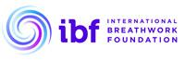

ibfbreathwork.org

